Window to Winter
by
Barlow Adams

I lay on the pond behind my mother’s house, as I have every winter cold enough to freeze since I was ten years-old, ear pressed against the surface, chill burning around the edges of my ear like flame under a stovetop chasing its tail.

The pain is intense. It takes measured effort to keep from breaking contact. The throb of blood in my earlobe, rushing to combat the frost, hot against the ice, a drum in my mind.

I hear the accompaniment. The low chirp of insects trapped within, the dull heartbeats of stilled fish, the water itself, an ocean in a glacial shell, frozen mid swell, poised in urgency, a steamy breath from freedom. I’m gone, only a smudge against the ice, a grasping handprint left on the window to winter. I release the warm air from my lungs, and am filled with December instead.

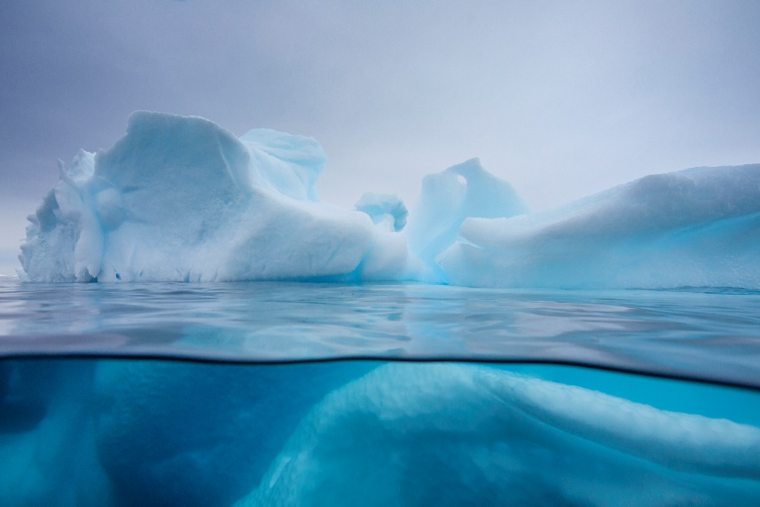

Barlow Adams winters in the Northern Kentucky area with his family and two snow hounds. He is exceedingly fond of hoarfrost and being solicited by lit mags. He eats winter berries even though he knows he shouldn’t and has many stomach aches as a result. He’s published in some cool places.

