Waxing Christmas
by
Amy Barnes

My great grandmother hung the moon.

Her rich tenor voice sang of o holy nights as she cut holey moon cookies, old-fashioned powdery anise crescents from the old-country, borrowed from the baker man in the moon. The recipe kept sewn in a skirt hem, she tossed cookies skyward, waiting for the sun to bake moon dough, both visible in days.

As winter night fell, she lit a delicate metal pyramid to flutter on Christmas far from its home, her home, the moon’s home. White hot candle stars gently spun clanking angels, night-lights against a licorice moon.

And then, that year - the year my great grandmother danced forever with the moon. I was the one who lit the delicate angel effigies and frantically cut open Goodwill-destined skirt hems to find the moon cookie recipe.

From mid night until mid-dawn, I toss cookies skyward to light the night sky for her.

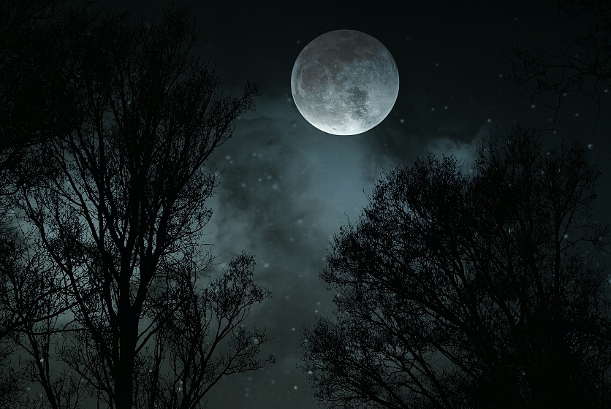

Amy Barnes is a writer and an editor. Her full-length flash collection is forthcoming from word west in 2022.

