Just A Bit
by
Shome Dasgupta

Amid a sunset—embedded in silence
and gleam as the world becomes soft
in its darkness—as the world
becomes a blanket and I shift my body
this way and that to gain a stronger
understanding of myself and you
so that we can soften the world, just a bit—
such as a middle of a winter sunset.

Early, the nights and days—so hand in hand
let’s wander forth into blinding days
and let us lift our chins, just a bit,
to let the sky welcome us into a moment of light—
a moment to carve out of marble
and we can settle into the dirt and soil,
still and quiet and still until we are overwhelmed
with evening songs—until our hands
feel like petals sprinkled with frozen dew.

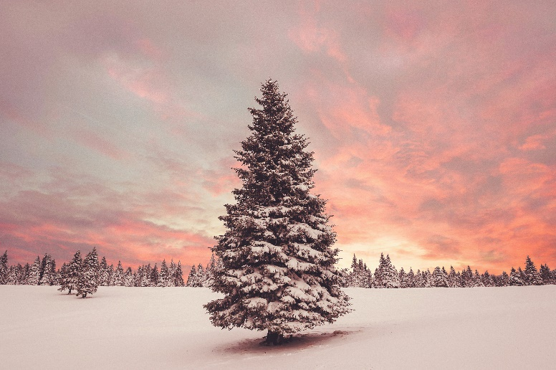

Shome Dasgupta is the author of seven books, including The Seagull and The Urn, Spectacles, and a poetry collection, Iron Oxide. He lives in Lafayette, LA and can be found at http://shomedome.com and @laughingyeti.

